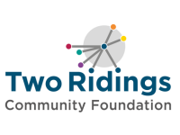

“Vital Signs” Research Project
Uncovering Community Assets, Needs and Opportunities

INVITATION TO TENDER

- Introduction

Two Ridings Community Foundation is a regional charity that helps people and businesses give with purpose, funding hundreds of community organisations across North and East Yorkshire every year.

As part of our partnership with Bettys and Taylors Ltd, we wish to commission research into the assets, needs and opportunities of communities in part of our region. The purpose of this research is to provide a robust evidence base to inform strategic decision-making, including future investment to strengthen these communities.
We are keen that the research draws on the Vital Signs methodology, used by Community Foundations across the world to uncover insights into the current issues and priorities facing communities, and combining published official data with qualitative methods that draw out people’s lived experiences.
The research should provide a detailed, place-based understanding of communities and generate evidence that can be used not only by Two Ridings and Bettys & Taylors, but also by other regional stakeholders including public sector partners, funders, businesses and voluntary and community organisations.

- Scope of work

Geography
The research should focus on communities within a 10-mile radius of Bettys Café Tea Rooms and the Bettys and Taylors Head Office in Harrogate, as per the following map:

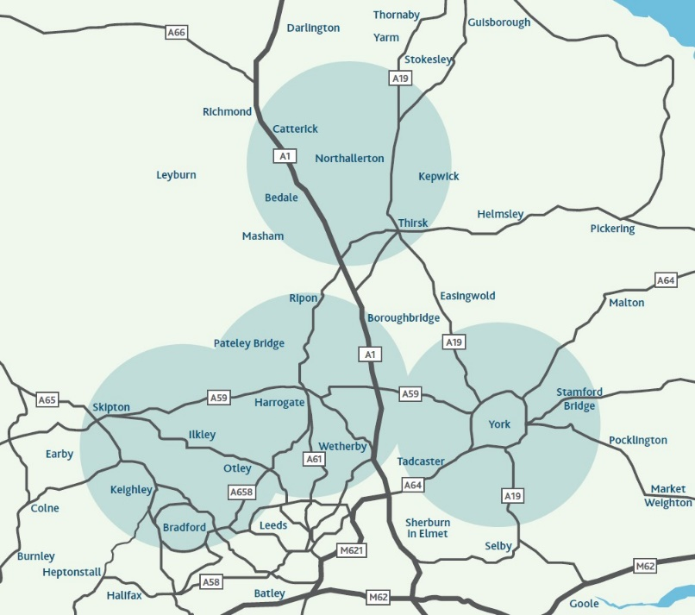

Thematic focus areas
The research should focus on the following seven Vital Signs indicators:
- The Economy: Local business growth, jobs, and financial security.
- Education: Schools, training, and learning opportunities for all ages.
- Health: Physical and mental well-being and health services.
- Environment: Green spaces, climate action, and pollution levels.
- Community: Belonging, social ties, and local group strength.
- Living Standards: Poverty levels, income fairness, and daily costs.
- Access: Ability to travel, use services, and connect online

Research questions
- What assets and strengths exist within these communities?
- Where are there opportunities to strengthen community capacity?
- What are the most significant issues affecting residents and communities?
- Which communities experience the greatest inequalities and challenges?
- What emerging needs require attention over the next five to ten years?
- Where can investment have the greatest impact?

- Methodology
The research must be grounded in the Vital Signs methodology and draw on recognised good practice in community research and engagement.
The successful provider should propose an approach that includes the following:
- Desk-based research, including analysis of existing datasets, strategies, policies and local plans
- Community engagement, whether by surveys, focus groups, workshops or other conversations
- Asset mapping, including identification of both formal and informal assets

- Outputs
The successful contractor will provide:
Inception phase: inception meeting, to agree a detailed project plan and methodology
Main report: a report of no more than 25 pages, plus executive summary
Presentation: workshop presentation of the report and discussion of findings, to be held in either Harrogate or York.

- Procurement process
Responses are invited between 10th August – 6th September 2026. There will be opportunities for questions submitted by email to info@tworidingscf.org.uk, to be answered between Monday 10th - Friday 14th August, and between Tuesday 1st September and Friday 4th September. The deadline for responses is 9am on Monday 7th September 2026.

All responses will be acknowledged and the successful bidder(s) will be informed by Thursday 17th September. If you have not heard from us by this date it means you have not been successful. If you would like feedback on your response please contact us after this date.

We anticipate contract(s) will commence on 28th September 2026, and we expect the main report to be completed by Monday 28th November 2026.

Your response should remain valid for 6 months from submission.

You will be expected to adhere to Two Ridings Community Foundation policies, including but not limited to:
- Standard terms and conditions
- Data Protection Policy
- Safeguarding Policy
- Privacy Policy
- Health and Safety Policy

- Instructions to bidders

In your response, please include the following:
- A summary of your expertise, relevant qualifications and experience as a researcher.
- A summary of relevant experience of or insight into the communities and places within the geographic scope of this research.
- An explanation of your approach to the research, including how you will bring an equity lens to all elements of the work.
- A brief description along with the total cost for activities.

Your response should be a maximum of six pages, and should be emailed to Celia McKeon on info@tworidingscf.org.uk .

For guidance, we have a maximum budget of £9,000, to include all costs and expenses. This excludes the costs of designing a digital copy of the report, which will be managed by Two Ridings.

Please supply the following supporting documents with your response:

- Public liability insurance
- Sample research report

5. Evaluation Criteria

Our priority is not cost alone, although value for money is one of our evaluation criteria.

We will also be assessing:
- Your alignment with our values.
- Your experience of community research, including your approach to bringing an equity lens
- Your understanding of and insight into communities in the geographical area covered by this project.

