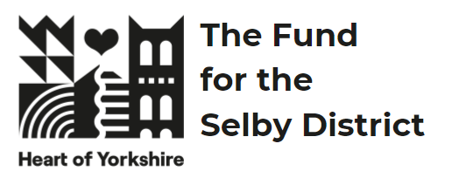 | The Heart of Yorkshire Fund for the Selby District  Guidance Notes, Round 2025-1 | 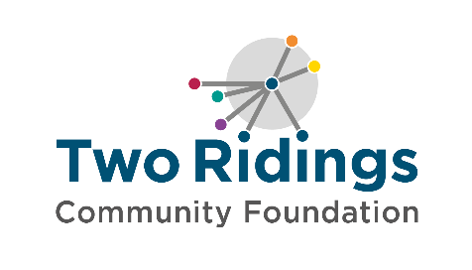

Overview
The Heart of Yorkshire Fund for the Selby District, was established by a £2million donation from Selby District Council, invested as an endowment fund with Two Ridings Community Foundation. The annual interest from this endowment will be awarded in grants to support local people to deliver activities in their community, year on year, forever.

This fund provides the local community with a lasting legacy: supporting local charitable activity in the former Selby District in a way that meets the identified needs in the area. Since the fund was established, Selby District Council has become part of North Yorkshire Council.

Fund priorities
This fund supports groups providing activity for the wellbeing of people in the Selby area (please see the map below). Organisations should clearing demonstrate how they are addressing local need in at least one of the following areas:

Health and wellbeing
- support older and vulnerable people to live dignified, productive and healthy lifestyles
- support children and young people to access and enjoy healthy lifestyles (this could be physical activity, access to the outdoors, improving their mental wellbeing)
- improve mental health and wellbeing.
Education and Training
- develop employability skills.
- provide volunteering opportunities.
Environment
- increased biodiversity
- support environmental improvements
Community Sector Resilience
- community spaces providing significant community value requiring funding to stay open.

We are also particularly interested in applications where people with lived experience (experts by experience) of the issues being addressed are involved with the design of the project and/or the running of the organisation / delivering the project.

Who can apply?
Heart of Yorkshire grants are targeted at organisations with a turnover under £500,000 with charitable aims where a small amount of money can make a significant difference. You can apply if you are based in or serving the residents of the former Selby district.
In the event of this fund receiving more applications than we have monies to support, the decision-making panel may prioritise organisations / groups with:
- a turnover below £250,000
- low reserves (under 6 months)
- ongoing projects that demonstrate deep community impact with a good track record.

If you currently have a Heart of Yorkshire Fund grant, you can only apply for the Organisation Development strand below. You cannot apply for an activity grant.

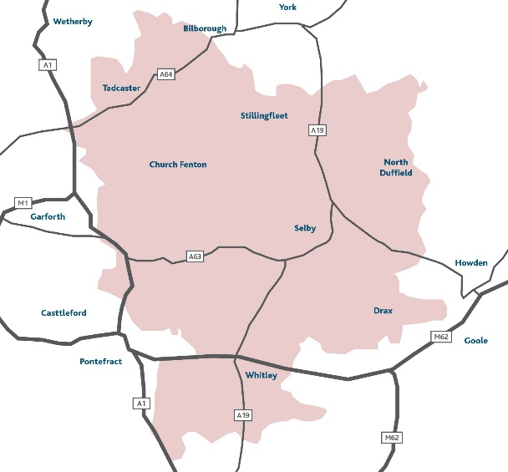

How much you can apply for
We have a total of £50,000 for this round of funding. This will be distributed as:

- 3 Organisational Development grants – up to £10,000 each
These grants are for groups to make a necessary ‘step change’ needed to increase their capacity or support them towards sustainability, and as part of that, to contribute towards running costs.

- 4 Activity grants – up to £5,000 each
Applications deadline – noon, Monday 17th February 2025

What grants can be used for
You can apply for either an activity grant (up to £5,000) to help address a gap in provision or an Organisational Development grant (up to £10,000).

The Heart of Yorkshire Fund is committed to the principle of full cost recovery to ensure that groups are supported with ongoing sustainability. As part of your application you can request a contribution towards core overhead costs (e.g. rent/ heating/ lighting etc). For further information about full cost recovery please see our guide.

Small capital items may be included as part of a bid but should not make up more than 20% of what you are applying for.

The fund may support larger capital costs for community venues with a maximum award of 50% of the total project costs (i.e if your repairs equal £10,000 you can apply for up to £5,000 maximum). These will be prioritised based on supporting the applying venues to stay open.

Applying for an Organisational Development grant?
An Organisational Development grant is to strengthen groups and organisations through making a necessary developmental ‘step change’ needed to become more stable and resilient. Organisational Development focuses on supporting groups towards sustainability through improving capability and / or capacity. You can use this funding to create or make changes to your strategy, structure or processes for an entire system, your overall organisation, an area of work or a specific role or job. For example, maybe you need your rental costs covering for six months whilst you work on establishing new income to cover future rent. Perhaps you would like to train your staff or volunteers so that they are better equipped. Or you recognise the need for increasing your administration hours to review policies and procedures. Examples of what the fund can support are below (this list is not exhaustive):
- Business planning and development
- Developing governance and leadership (e.g. charity registration or registration as a form of social enterprise)
- Developing monitoring and learning
- Fundraising planning and development (note – we cannot fund commission-based work)
- Increasing leadership capacity to support collaboration and partnership working
- Marketing and communications
- Piloting a project that could create a new revenue stream
- Purchasing software to support your organisation
- Staff, key volunteer and trustee training
- Testing new ways of working
- Small capital costs (small capital items can form part of the budget but should not make up more than 20% of the amount applied for)
Applying for an Activity grant?
You can apply for direct activity / project costs and pilot projects. Grants can fund 100% of the activity costs or can be part of a combination of funding to meet the full amount needed, however it is unlikely that priority will be given to projects where the grant award would represent less than 20% of the total project cost. If you are applying for a percentage of the total costs, please tell us what other funding has been secured or how you will secure the remaining funds.

Some examples of what an Activity grant can support are below (this list is not exhaustive):
- Befriending schemes
- Activities to bring people together
- Information, advice and guidance
- Sporting activity
- Transition work for children going from primary school to secondary school
- Counselling and peer support groups
- Peer support groups
- Volunteer recruitment and training
- In Bloom groups

General Eligibility
In order to apply to the Heart of Yorkshire Fund your organisation must be:
- Either a small voluntary organisation, community group, small charity or other type of not-for-profit organisation provided that the purpose of the grant is wholly charitable (please see our FAQs for additional requirements for CICs & CBSs )
- Be based in and / or delivering activities or services in the Selby area (see map above)
- Have a governing document (also known as a constitution, rules, memorandum, or articles of association) in the name of their organisation outlining charitable objectives and with a charitable dissolution clause
- Have a bank account in your group/ organisation’s name with at least two signatories, who are not related to one another
- Have an annual income of under £500,000 per annum

All groups should meet our general eligibility criteria which can be found here: https://www.tworidingscf.org.uk/how-to-apply

Who and what cannot be funded?
Applicants who currently hold an active Heart of Yorkshire grant can only apply for an Organisational Development grant.

- Private Businesses or individuals  - General appeals or sponsorship  - National organisations and their affiliates  - Work which has already started or taken place / retrospective funding  - Work normally funded from statutory sources  - Work undertaken by or on behalf of statutory bodies as part of their statutory activities  - Prize money  - Purchase of gifts  - Work of a political nature  - Loans, deposits or on-granting | - Work undertaken by/ on behalf of schools, colleges or universities as part of their statutory curricular activities  - Work where the main beneficiaries are animals  - Work which does not directly benefit people living in the area of benefit  - Overseas holidays or trips  - Organisations that mainly give funds to other organisations or individuals  - Work for the advancement of religion (applications are accepted from religious groups working in the community provided that the main focus of the project is not proselytising)  - Work normally undertaken by infrastructure organisations

How to apply
- Ensure you meet all the eligibility and fund criteria above and that the fund is currently accepting applications.

- Complete the online application form. A link to this is found on the Heart of Yorkshire Fund page of the Two Ridings website. The online application process is straightforward and provides an option to save your application as you go so you can dip in and out of the application before you submit it. If required a paper version of the application form is available on request.

- Attach your supporting documents (listed below) to the online application or if you have requested a paper version of the application form, please send the complete form along with copies of your supporting documents to: Two Ridings Community Foundation, Pavilion 2000, Amy Johnson Way, YO30 4XT.

- The organisations constitution/governing document/set of rules
- Contact details (address, email & phone number) of your management committee / trustees / directors.
- The organisations most recent annual accounts or financial records that show your organisation’s balance of funds, income and expenditure. If you do not have financial records that cover a full year then you will need to provide a set of management accounts.
- A safeguarding policy if your organisation works directly with children or vulnerable adults.

Applications will only be processed when all documentation has been received.

If you do not have all these documents, please do get in touch, we may still be able to consider your application or signpost you to further support.

- If your application is successful, you must provide a copy of a Bank Statement (dated within the last three months) or Paying In slip in the name of the organisation applying. We can not accept transaction lists or screenshots of transaction. Click here for some guidance on your bank statement.

Assessment and Award
- All eligible applications will be assessed. One of our volunteer or in-house assessors may contact you to chat about your application to help us better understand your funding request. This may be over the telephone or in person. When assessing applications, we will look at the following:
  - How your group/activity is set up and managed
  - How well your finances are managed
  - Evidence of need for your project
  - Your commitment to ensuring equal opportunities and the inclusivity of your project
  - Value for money offered by the project
  - How well the project meets the fund criteria and the priorities.
- All eligible applications will be considered by a funding panel, which may include community members, people with lived experience and / or donors, and Two Ridings Grants committee members. The final decision cannot be changed and no discussion will be entered into although we will try to provide constructive feedback if we can. In certain circumstances applicants will be awarded a pledge. This is the promise of a grant if/when certain conditions are met.
- There is no appeals process for grant awards. If an applicant feels dissatisfied with the outcome they can make a complaint and our complaints policy provides the detail of how to do this.
- Following the panel meeting, we will contact you by email to let you know the outcome. We aim to give you a decision within 8 weeks of the application deadline.

Monitoring and Evaluation
  - When your project is complete, you must fill in an End of Grant Monitoring Form. This is available as an online form very similar to the online application form and should your application for funding be successful the link to your end of grant report will be sent to you when your grant payment is made. After your grant period, you will not be eligible to apply for further grants from this scheme until we have received this form as it finalises your grant.
  - We aim to undertake monitoring visits on a proportion of funded applications and we will contact you to arrange a visit if this is required.
  - Successful applicants must ensure that Two Ridings is included in any publicity and our logo’s will be provided for this purpose.

Equality, Diversity and Inclusion
Two Ridings is committed to equality, diversity and inclusion and ensuring an equity of access to all groups and organisations. We expect groups and organisations applying for grants to show that they are aware of equality, diversity and inclusion and can demonstrate commitment to them.

Application queries and support

If you require any assistance with the completion of your application please contact Two Ridings on 01904 929500. We are happy to help.

Should you need further fundraising discussions and support then please contact our partners Up for Yorkshire, your local VCSE support organisation. They can offer help to work up a project idea, share local knowledge and to provide connections to partners and venues should this be required. https://upforyorkshire.org.uk

