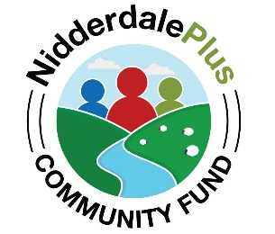 | Nidderdale Plus Community Fund Guidance Notes | 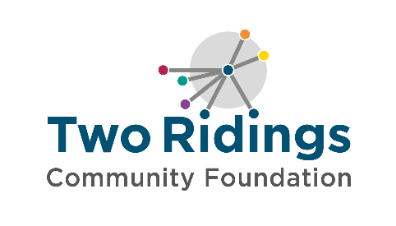

Overview
The Nidderdale Plus Community Fund has been established by Nidderdale Plus, who are donating a portion of the income from their charity shop in Pateley Bridge. The fund aims to provide a sustainable source of funding to support local small, grassroots organisations delivering charitable activity in Nidderdale. The priorities will be updated each year, in line with local need and opportunity.

Fund priorities
We would particularly like to receive applications from organisations who are:
- Improving community wellbeing and social inclusion
- Fostering independence
- Cultivating a sense of belonging
- Community energy needs
- Improving community spaces and facilities for local residents

We will give priority to applicants that:
- can evidence demand
- are working with people who need extra support to stay independent and well

What grants can be used for
Grants can fund 100% of the activity costs or can be part of a combination of funding to meet the full amount needed, however it is unlikely that priority will be given to projects where the grant award would represent less than 20% of the total project cost. If you are applying for a percentage of the total costs, please tell us what other funding has been secured or how you will secure the remaining funds. You can apply for direct delivery costs for community inspired and led projects, activities and events. We expect that applications should reflect the concerns and priorities of the target beneficiaries and fit well with existing community services/activities.

Below are some examples of the type of costs that could be supported (this list is not exhaustive):
  - Staff and / or freelancer costs to deliver activity
  - Volunteer training and management
  - Life skills training, such as literacy, communication, IT
- Events that can demonstrate impact beyond the event itself
- Accessibility improvements (e.g., ramps, hearing loops)
- Venue hire for coffee mornings, lunch clubs, or wellbeing sessions.
We can support a Full Cost Recovery contribution towards core overhead costs (rent/ heating/ lighting etc) as part of your application. However, we cannot accept applications where overhead costs are a large proportion of the requested amount. Please note that overhead costs must not include any costs associated with commission-based payments for fundraising.

Please note – this fund only accepts full cost recovery and overheads relating to direct delivery. We can also accept applications that are predominantly for overhead costs.

Who can apply?
You can only apply if you are based in and/or serving people living in Nidderdale, as indicated in the shaded area on the map below, and your annual turnover is under £200K. Nidderdale Plus Community Fund 2026 grants are targeted at where a small amount of money can make a significant difference to the local community.
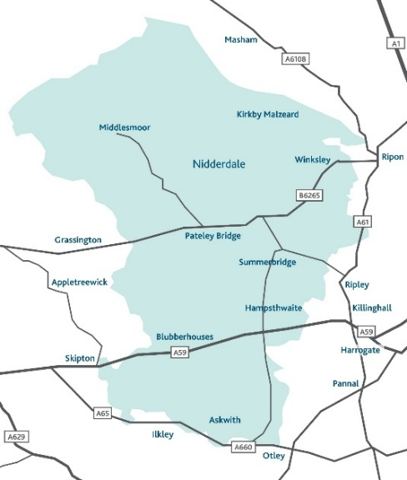

How much you can apply for
In this round, grants will be available of up to £2,000. It is anticipated that the expenditure would be completed within 18 months of the grant award.
Whilst we welcome repeat applications, these may be given lower priority depending on demand for the fund.

Organisational / Group Eligibility
Please read our How To Apply page on our website for essential information on:
- Organisational / Group Eligibility
- Who and what cannot be funded?
- How to apply
- Assessment and Award
- Reporting and Evaluation
- Equity, Diversity and Inclusion

How to apply
Applications deadline - noon on 16th March 2026
Decisions will be communicated by mid-May 2026

Applications will only be processed when all documentation has been received. If you do not have all these documents, please do get in touch on 01904 929500 prior to the deadline.
NOTE – if successful, you must submit your bank statement within 4 weeks of your ‘grant awarded’ notification otherwise your application will be withdrawn. Please make sure you have access to a statement when you apply.

