 | Cost of Living Crisis Fund  Guidance Notes  East Yorkshire & Hull | 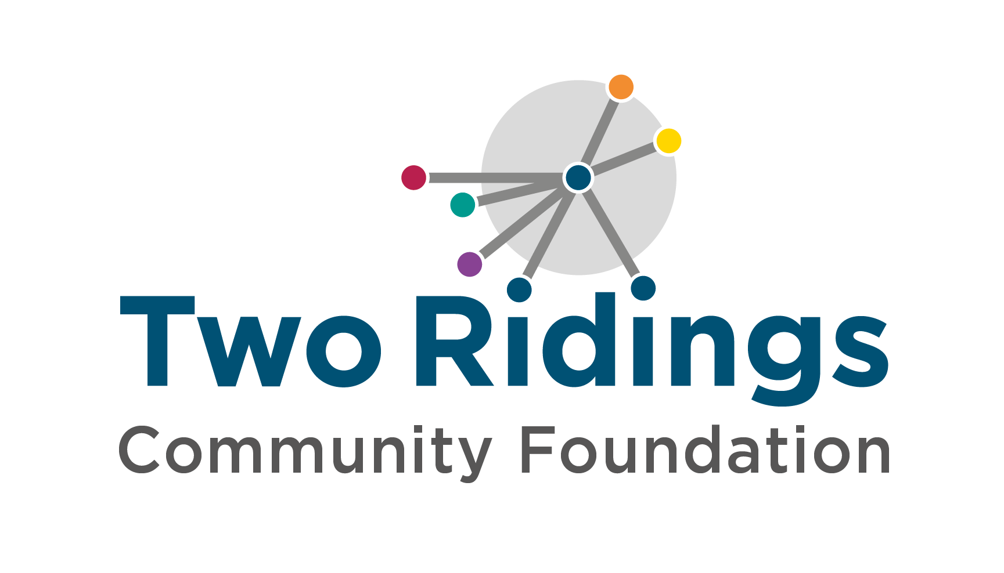

Overview
These are the guidance notes for organisations in East Yorkshire and Hull. If you are in North Yorkshire, please refer to those guidance notes.

The Cost of Living Crisis Fund has been created as a response to the spiralling cost of living. Demand for the fund is high. It is likely only possible for us to make a contribution towards total project costs. The fund enables groups to support their community during this crisis. We recognise, and our donors recognise, that the current situation is already deeply impacting our communities and the organisations that we support, and will continue to do so.

Amount Available

Grants up to £5,000
These grants can be used to provide emergency support in the form of food support, fuel support or purchasing essential items for distribution to local people. It could also be used to enable your organisation to provide activities, or create a warm and welcoming space, for people affected by the cost of living crisis.

Grants up to £10,000
For these grants we would expect funding to provide emergency support to local people as outlined above – this should be between 20% to 50% of your total ask. For community groups playing a significant role supporting their community, the reminader of your ask can also be used to support your core overheads.

Groups must:
- Be based in East Yorkshire or Hull
- Have a management committee with at least 3 unrelated members
- Be a voluntary organisation, community group, small charity or other not for profit organisation
- Have a bank account in the group’s name (with two unrelated signatories)
- As a general guide we consider a small charity to have an income of under £500k per annum. If your income is over this we may still be able to fund you. However, we ask that you contact us before making an application.

Who cannot apply/ what work will not be supported?
- Individuals
- Private Businesses
- National organisations and their affiliates
- General appeals or sponsorship
- Work normally funded from statutory sources
- Work undertaken by/ on behalf of schools, colleges or universities as part of their statutory curricular activities
- Work undertaken by or on behalf of statutory bodies
- Work for the advancement of religion
- Work where the main beneficiaries are animals
- Work which does not directly benefit people living in the area of benefit.
- Overseas holidays or trips

The Process

Applying

- Complete the online application form and attach supporting documents. If supporting documents cannot be attached then please forward these by email to grants@tworidingscf.org.uk

If you experience any difficulties with completing the application or providing any of the requested documentation please let us know via email.

Award
- An assessor may contact you to obtain further information however we will try to keep this to a minimum.
- All Applications are considered by a local panel and the final decision cannot be changed.
- We will aim to get a decision to you within 6 weeks of your application.
- We will contact you by email to let you know the outcome. When we contact you we will copy in a trustee/member of your management committee so it is important that we have email addresses for your Board members.
- If your application is successful, provided we have everything we need, your payment will be made on the next payment run following your offer email, usually within two weeks.

If you require any assistance with the completion of your application, please contact Two Ridings Community Foundation on 01904 929500.

