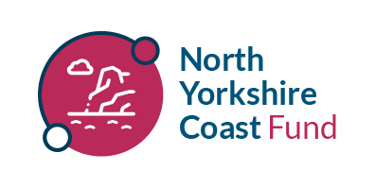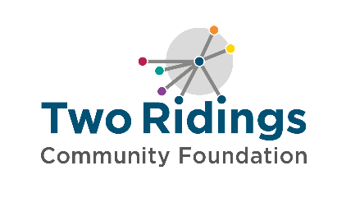
North Yorkshire Coast Fund
Guidance Notes

Overview
The North Yorkshire Coast Fund has been developed for the wellbeing of people and communities in the former borough of Scarborough. Within this, priority is given to work with children and young people to thrive and to help promote good mental health.

Projects should be working towards addressing at least one of the following:
- Increasing and/or improving mental health and wellbeing provision for young people
- Empowering and enabling young people to take an active role in the designing and delivery of activities in their communities
- Enable people to build social interaction / have conversations about challenging topics
- Community cohesion, celebration and integration activities
- Community activities that bring people and neighbourhoods together to address key issues identified by the community

Fund priorities for this round are focusing on:
- Improving men’s and boy’s mental health and wellbeing
- Inclusive sports
- Improving access to non-traditional
- Supporting girls into sports
- Using music and drama to improve health and wellbeing.
- Priority will be given to groups and projects outside of the town of Scarborough

Examples of what funding can be used for
We are open to considering a wide range of projects and keen to have a variety of activity that supports the communities and young people in the former borough of Scarbrough.

- Activities that support people who may be experiencing loneliness and isolation
- Activities to bring people together, including projects in music, arts and sports
- Activities that encourage people to be active, particularly projects that aim to break down barriers to participation
- Activities that enable young people's voices to be heard in community forums, processes and decisions that shape their lives.
- Information, advice and guidance
- Mental health support, including counselling, peer support and mentoring
- Debt and money advice

The list of possibilities above is not exhaustive and we will be running an introductory session for potential applicants to start to explore ideas.

Area of benefit
The area of the former borough of Scarborough.
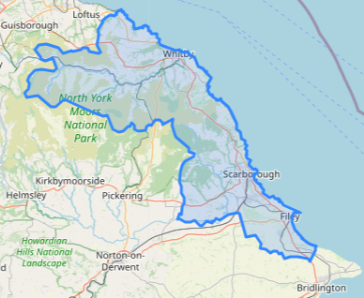

General Eligibility
In order to apply to the North Yorkshire Coast Fund your organisation must be:
- Either a small voluntary organisation, community group, small charity or other type of not-for-profit organisation provided that the purpose of the grant is wholly charitable (please see our FAQs for additional requirements for CIC’s and CBS’s)
- Be based in or delivering services in the former Borough of Scarborough
- Have a governing document (constitution, rules, memorandum, or articles of association) in the name of their organisation outlining charitable objectives and with a charitable dissolution clause
- Have a bank account in your group/ organisation’s name with at least two signatories, who are not related to one another
- Have an annual income of under £500,000 per annum based most recent submitted accounts or current years income forecast (Locally led, grassroots groups.)

Organisational / Group Eligibility
Please read our How To Apply page on our website for essential information on:
- Organisational / Group Eligibility
- Who and what cannot be funded?
- How to apply
- Assessment and Award
- Reporting and Evaluation
- Equity, Diversity and Inclusion
Grants
You can apply for grants between £500 and £5,000 for projects lasting up to 12 months.

Closing date: 12 noon on Monday 6th April.
Decisions will be communicated by the end of May2026

Applications will only be processed when all documentation has been received. If you do not have all these documents, please do get in touch on 01904 929500 prior to the deadline.
NOTE – if successful, you must submit your bank statement within 4 weeks of your ‘grant awarded’ notification otherwise your application will be withdrawn. Please make sure you have access to a statement when you apply.

An application link can be found on our website at https://www.tworidingscf.org.uk/fund/north-yorkshire-coast-fund/

Delivery of projects focused on young people should take place outside the school setting and typical school day.

The fund will support direct project costs. The fund is committed to the principle of full cost recovery to ensure that groups are supported with ongoing sustainability. For further information about full cost recovery please see our guide.

