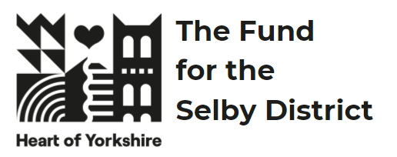 | The Heart of Yorkshire Fund for the Selby District  Guidance Notes 2026 | 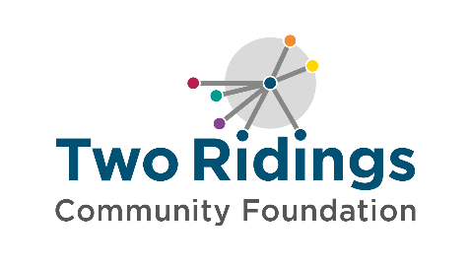

Overview
The Heart of Yorkshire Fund for the Selby District, was established by a £2million donation from Selby District Council, invested as an endowment fund with Two Ridings Community Foundation. The annual interest from this endowment will be awarded in grants to support local people to deliver activities in their community, year on year, forever.

This fund provides the local community with a lasting legacy: supporting local charitable activity in the former Selby District in a way that meets the identified needs in the area. Since the fund was established, Selby District Council has become part of North Yorkshire Council.

Fund priorities
This fund supports groups providing activity for the wellbeing of people in the Selby area (please see the map below). Organisations should clearing demonstrate how they are addressing local need in at least one of the following areas:

Health and wellbeing
- support older and vulnerable people to live dignified, productive and healthy lifestyles
- support children and young people to access and enjoy healthy lifestyles (this could be physical activity, access to the outdoors, improving their mental wellbeing)
- improve mental health and wellbeing.
Education and Training
- develop employability skills.
- provide volunteering opportunities.
Environment
- increased biodiversity
- support environmental improvements
Community Sector Resilience
- community spaces providing significant community value requiring funding to stay open.

We are also particularly interested in applications where people with lived experience (experts by experience) of the issues being addressed are involved with the design of the project and/or the running of the organisation / delivering the project.

Who can apply?
This fund is open to organisations whose activities take place within former Selby district, the area designated on the below map. Priority will be given to groups based in and delivering services in this area.

In the event of this fund receiving more applications than we have monies to support, the decision-making panel may be unlikely to prioritise organisations / groups:
- with significantly high reserves where it appears these could reasonably be used for the proposed activity or development;
- without a good track record and unable to demonstrate deep community impact;
- an income trajectory that would push them above the fund’s income ceiling within the delivery timeframe

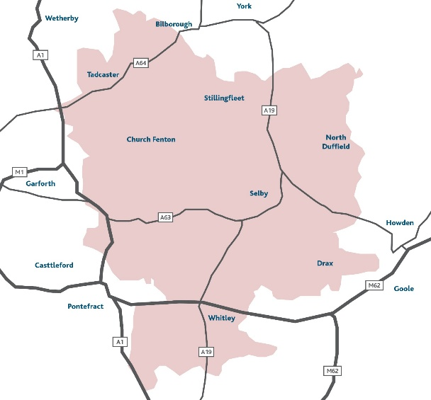

How much you can apply for
Grants are available up to £10,000 per year for a maximum of two years (total grant up to £20,000)
This year we have a total funding pot of £100,000 (we expect to fund approximately 5–15 grants this round)

Applications deadline - noon on Monday 10th August 2026.
Decisions will be made in September by a special panel made up of members of the community and representatives of Two Ridings Community Foundation. You will hear from us with a decision by the end of September.

Funding can be towards pilot projects, providing activity, projects or support or for small capital items (all types of application will be treated equally). Grants can fund 100% of the activity costs or can be part of a combination of funding to meet the full amount needed. However, it is unlikely that priority will be given to applications where the grant award would represent less than 20% of the total project cost. If you are applying for a percentage of the total costs, please tell us what other funding has been secured or how you will secure the remaining funds.

Please note – We support Full Cost Recovery and strongly encourage applicants to include a proportion of their overheads on this application, excluding costs associated with commission-based payments for fundraising. We do not accept applications for overheads alone or where overhead costs are a large proportion of the requested amount.

What grants can be used for
The fund may support larger capital costs for community venues with a maximum award of 50% of the total project costs (i.e if your repairs equal £10,000 you can apply for up to £5,000 maximum). These will be prioritised based on supporting the applying venues to stay open.

Some examples of what a grant can support are below (this list is not exhaustive):
- Befriending schemes
- Activities to bring people together
- Information, advice and guidance
- Sporting activity
- Transition work for children going from primary school to secondary school
- Counselling and peer support groups
- Peer support groups
- Volunteer recruitment and training
- In Bloom groups

Organisational / Group Eligibility
Please read our How To Apply and FAQ pages on our website for essential information on:
- Organisational / Group Eligibility
- Who and what cannot be funded?
- How to apply
- Assessment and Award
- Reporting and Evaluation
- Equity, Diversity and Inclusion

How to apply
- Ensure you meet all the Organisational / Group eligibility above detailed on our How To Apply web page.
- Ensure you meet the fund criteria and at least one of the fund priorities above and that the fund is currently accepting applications.
- Complete the online application form. Links to this can be found on the Two Ridings’ website.

NOTE:
- Applications will only be processed when all documentation has been received.
- If successful, you must submit your bank statement within 4 weeks of your ‘grant awarded’ notification otherwise your application will be withdrawn. Please make sure you have access to a statement when you apply.

Oversubscription Process
- All organisations will first be checked against the published eligibility criteria. Only submissions received before the deadline that clearly meet these criteria will progress to further consideration.
- Eligible applications will then be assessed against the fund’s core criteria and priorities. This may include (but is not limited to):
- Strategic fit with the fund’s objectives
- Expected impact and value for money
- Strength of the organisation
- Deliverability within the required timeframe
- Where applications are of a similar standard, additional factors may be considered to ensure a balanced portfolio of activity. These may include:
- Alignment with identified priorities
- Geographic spread
- Diversity of applicant types
- Where Expressions of Interest (EOI) are submitted, only the highest-scoring EOI’s will be invited to submit a full application. Being invited to the next stage does not guarantee funding.

