Rusholme Wind  Farm Fund | Guidance Notes | 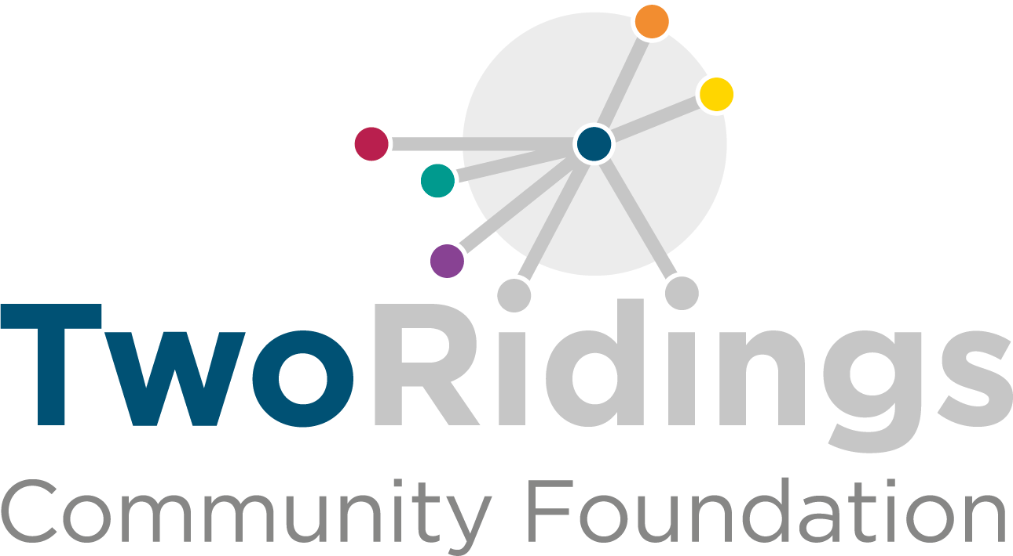

Overview

The Rusholme Wind Farm Fund is designed to help voluntary organisations, community groups and small charities based in and/or serving the communities of the parishes of Newland, Airmyn, Drax and Long Drax (the area of benefit). Applications from those parish councils will also be considered.

You can apply for grants that support charitable activities that:

- Carbon emission reduction projects
- Sustainable energy projects
- Energy efficient projects
- General environmental projects
- Community benefit and enhancement projects

Funding Available

Grants are available of between £250 and £4,000 for:

- Voluntary organisations, community groups, small charities and other types of not-for-profit organisation provided that the project is wholly charitable. Priority will be given to those based in or operating for the benefit of the parish council areas of Airmyn, Drax, Long Drax and Newland.
- Parish councils may also apply provided that the project is wholly charitable and falls outside of their usual remit.
Larger grants and multi-year funding (up to £15,000) will also be available for exceptional projects which can demonstrate significant community benefit, this may mean projects which will provide benefit for a significant number of people, those with a lasting and sustainable community benefit or those that provide a significant benefit for a smaller number of people who may be particularly disadvantaged.
Larger grants and multi-year requests could include but are not limited to: -

- Refurbishment of community buildings or other local assets
- Community transport or digital projects for isolated areas
- Community leisure facilities
- Outreach & support services for people in rural isolation

Priority will be given to work which:

- Addresses needs identified by local people
- Fulfils needs not already being met
- Supports community involvement
- Demonstrates a commitment to equal opportunities through activity
- Projects where the grant covers a significant proportion of the costs

When to Apply

Deadlines for 2024 are:
24th April 2024 (12.00 midday)
20th August 2024 (12.00 midday)

Eligibility

Your groups must:
- Serve the communities of Newland, Airmyn, Drax and/or Long Drax
- Have a governing document (constitution/ rules/ memorandum/ articles of association) with a suitable dissolution clause
- Be a voluntary organisation, community group or small charity
- Have a bank account in the group’s name
- Have been in existence for at least 6 months

The Rusholme Wind Farm Community Benefit Fund welcomes applications from charitable and voluntary groups with very few exceptions. The information below applies to all applicants.

Who can apply? | Who cannot apply / what work will not be supported?
- Registered charities  - Smaller groups and parish councils, that may not be registered as a charity provided that the purpose of the grant is wholly charitable and in the case of a parish council that the project is outside of its usual remit  - Other types of not for profit organisation for work which is wholly charitable. | - Private Businesses  - General appeals or sponsorship  - National organisations and their affiliates  - Work which has already started or taken place  - Work normally funded from statutory sources  - Work undertaken by or on behalf of statutory bodies  - Work undertaken by/ on behalf of schools, colleges or universities as part of their statutory curricular activities  - Work for the advancement of religion  - Work where the main beneficiaries are animals  - Work which does not directly benefit people living in the area of benefit  - Overseas holidays or trips.

The Process
- Applying
  - Ensure you are eligible and that the fund is currently accepting applications.
  - Complete the online application form. A link to this is found on the Rusholme Wind Farm Community Benefit Fund page of the Two Ridings Community Foundation website, www.tworidingscf.org.uk.
The online application process is the easiest way to apply. You can dip in and out of their application saving changes as you go. Please get in touch if you need support with the form. If required a paper version of the application form is available on request from the Foundation.

  - Attach your supporting documents to the online application or email them to grnats@tworidingscf.org.uk. Or send these by post to Rusholme Wind Farm Community Benefit Fund, C/o Two Ridings Community Foundation, Pavillion 2000, Amy Johnson Way, York, YO30 4XT

If the full supporting documentation is not received within 4 weeks of the date of submission of the online or paper application, or by the advertised closing date where applicable, the application will be withdrawn. Applications will only be processed when all documentation has been received.

- Assessment and Award
  - All eligible applications will be assessed. An assessor may contact you to obtain further information or to arrange an evaluation. This may be over the telephone or in person.
  - All applications are considered by the Rusholme Wind Farm Community Benefit Fund Panel and its recommendations are ratified by Two Ridings Community Foundation’s Board of Trustees. The final decision cannot be changed and no discussion will be entered into although constructive feedback will be provided where possible. In certain circumstances applicants will be awarded a pledge. This is the promise of a grant if / when certain conditions are met.
  - Following the panel meeting, you will be contacted by email to inform you of the panel’s decision.
- Monitoring and Completion

  - When your project is complete, you must fill in an End of Grant Monitoring Form. This is available as an online form very similar to the online application form and should your application for funding be successful the link to your end of grant report will be sent to you when your grant payment is made. You will not be eligible to apply for further grants from this scheme until we have received this form as it finalises your grant.

The online monitoring form is the easiest way to complete end of grant reporting requirements, it provides applicants with the ability to dip in and out of their final report saving changes as they go, support is also available from the Foundation to assist applicants completing their reporting in this way. If required however a paper version of the monitoring form is available on request from the Foundation.

  - The Foundation aim to undertake monitoring visits on a proportion of funded applications and will contact you to arrange a visit if this is required.
  - Publicity is very important to assist in the promotion of the fund to other potential applicants and in the promotion of funded projects to the local community. The Foundation has standard terms and conditions relating to publicity
- Photographic and publicity rights are reserved as a condition of funding.
- All publicity will acknowledge the Rusholme Wind Farm Fund and Two Ridings Community Foundation in full. Funding should be described as Funded by the the Rushome Wind Farm Fund administered by Two Ridings Community Foundation.

If you have any questions, please contact Two Ridings Community Foundation on 01904 929500 or email grants@tworidingscf.org.uk

